First of all, we install Node js 16.x(which is latest and stable version) on our local VM using the following commands:

Curl -fsSl https://deb.nodesource.com /setup_16.x | sudo -E bash
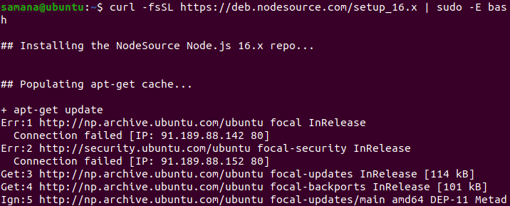

sudo apt-get install -y nodejs
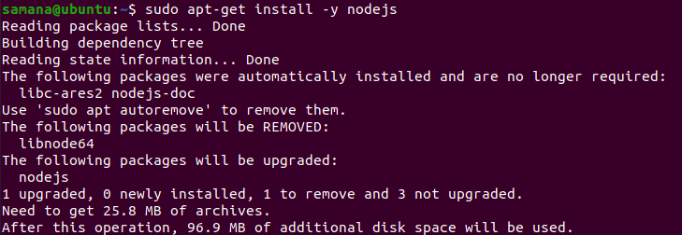

sudo apt-get install -y build-essential
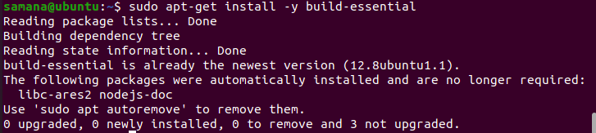

After installing node, we can verify it with the following commands:

node --version
npm --version
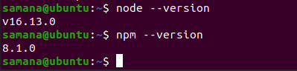

Now, inside the /var/www directory, we create a folder named nodeapp1 inside which we create a nodejs application.

Now we initialize the directory for a nodejs application.
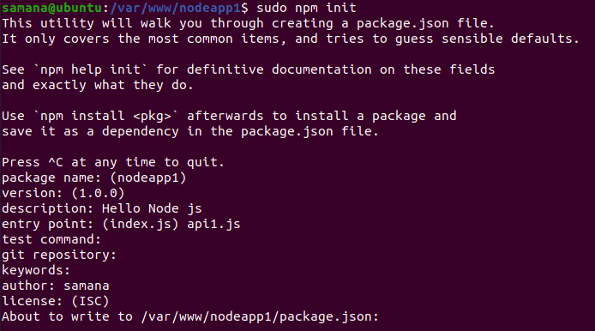

Now we edit the api1.js file to put the content “Hello Node JS” and make the application running on 6080.
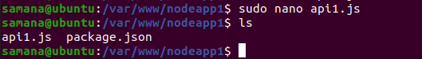

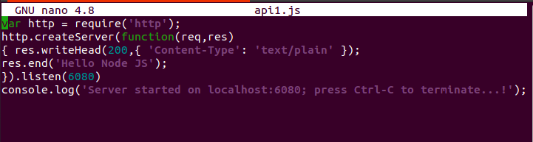

Now to start the node API we perform,
node api1.js
Therefore, the node application was found to be running on localhost 6080 as follows:

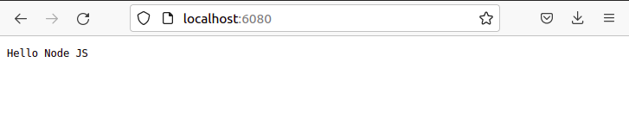

similarly we create a folder named nodeapp2 for the second node app and initialize the node application as follows:
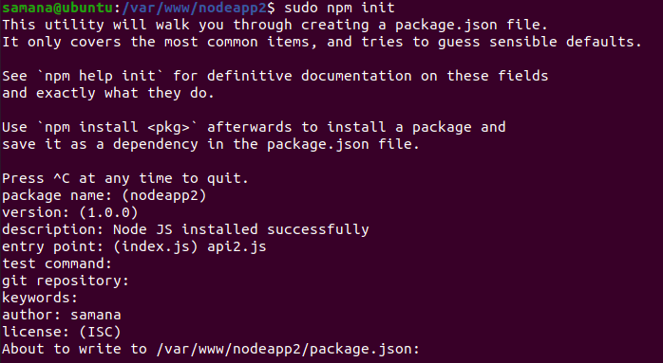

The api2.js file was edited to make the app run on port 7080 and display the message “Node JS installed successfully”
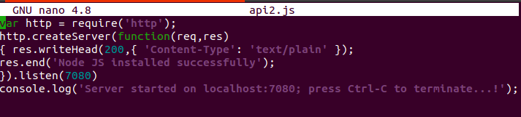

Now the server was started using the following command.

It was found to be running on port 7080 as we had set it.
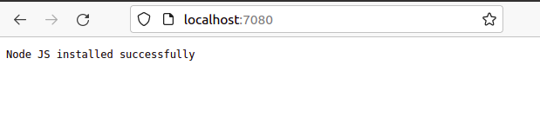

Pm2 is a production-level process manager for Node. js with a built-in load balancer
which was installed from the command given below:
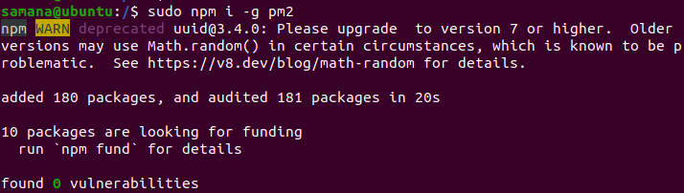

We can verify the installation by checking the version using the following command.
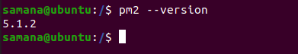

Now we start 4 cluster or 4 instance of the first api(using command sudo pm2 start api1.js -i 4) which can we verified from the table below.
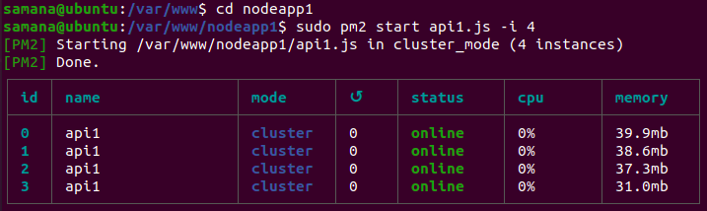

Similarly we create 4 instances of the second api.

Here every instance of an api is associated with a id
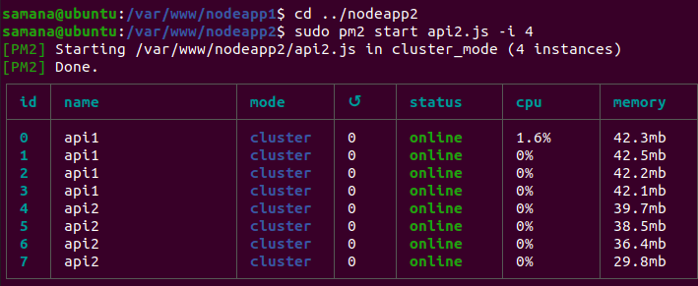

Here we have successfully deployed both APIs from pm2 in a efficient manner
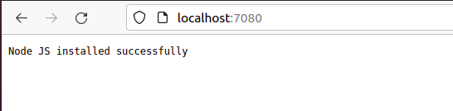

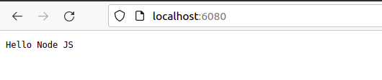
Now in order to delete the four clusters one by one from both APIs
We use the command sudo pm2 delete #pid

Here we deleted the first instances of both APIs which had process ids 0 and 4 respectively
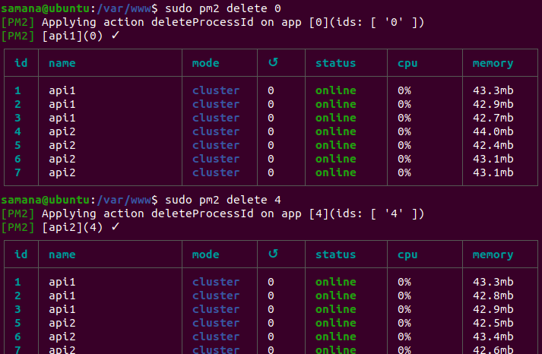

Similarly we deleted the second instance of both APIs
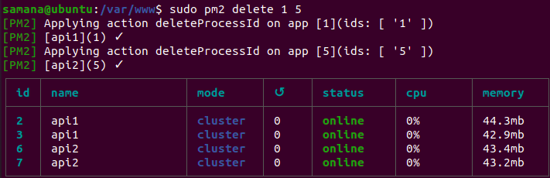

The third and fourth instance of both APIs were deleted one by one as follows:

And after running pm2 list command there were no instance of any API running because we deleted every instance one by one.
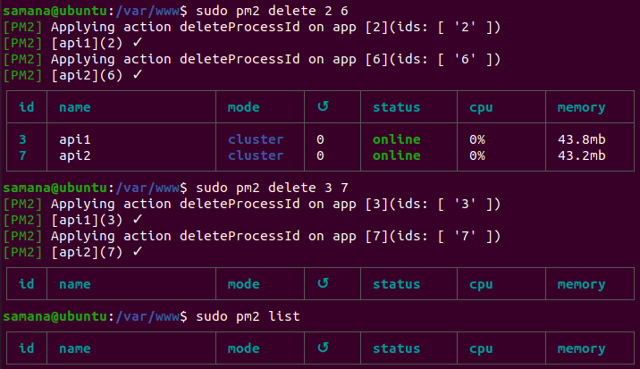

Now for creating a react application as we have npm already installed, we install the create-react-app utility as follows:
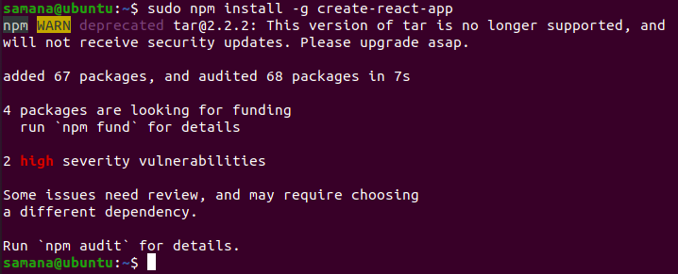

Now we create a react app named demoreactapp inside /home/samana
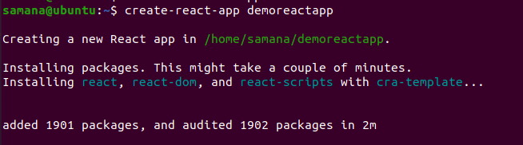

Now after running npm start we can see the following
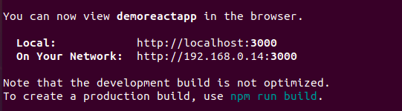

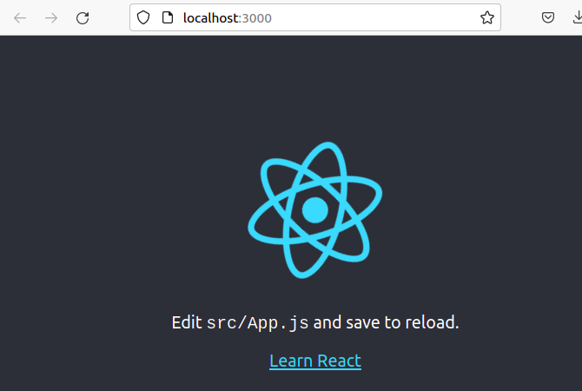

Now to build a react app according to our requirement(to display the “Hello react.js” message), we edit the App.js as follows.
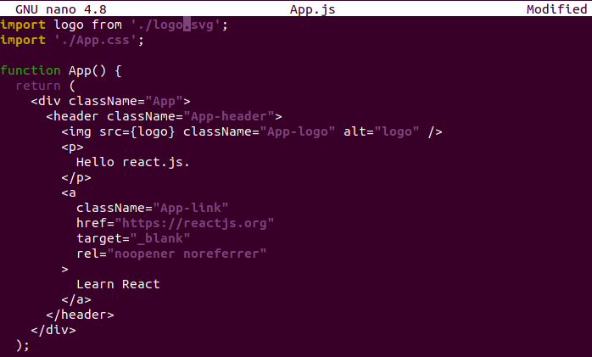

Now, to change the port no to 3001 we edit the package.json file

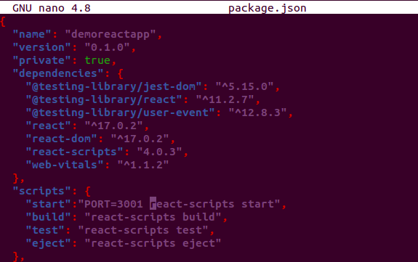

After editing the above two files we start the application
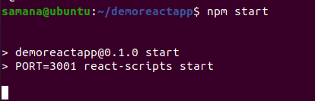

Finally we are able to see the application running on port 3001 and the message Hello react.js

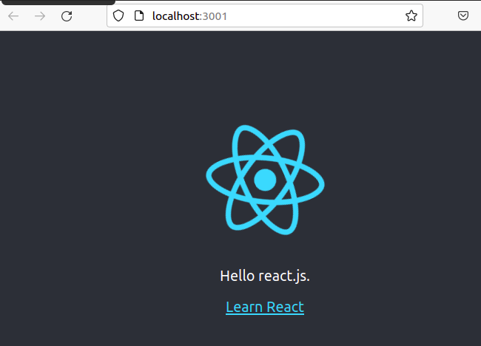

Problems occurred and Findings:

During installation i tried to install node 14.x but was unable to do so (probably because the server was down for few hours) so i went to the official node site and found that the LTS version was 16.x. Luckily i was able to download it.

when i had run npm start and node api.jsto run the application directly, I accidentally closed the terminal or hit ctrl C, and the running application was stopped.

however when I used pm2 the application continued running until I manually killed the process associated with it. That means the pm2 was running as a background process which increased the reliability.

Also, i came to know that the earlier direct deployment from the node api.js command is not suitable for several users while on the other hand, from pm2 different clusters or instances can be created which increases the performance and reliability of our applications

